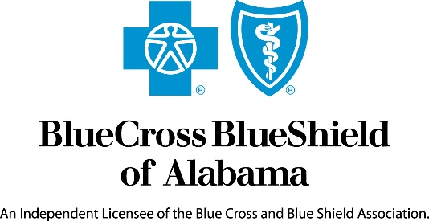

Media Release Contact: Koko Mackin
August 25, 2020 205-220-2713

Blue Cross and Blue Shield of Alabama Commits $230 million
In Support of the Ongoing Fight against COVID-19

Birmingham, AL – Blue Cross and Blue Shield of Alabama has paid, contributed and made available $230 million in the ongoing fight against COVID-19 supporting its members, employer customers, providers, and the community across Alabama. On a national basis, the 36 Blue Cross Blue Shield companies and the Blue Cross and Blue Shield Federal Employee Program have committed nearly
$3 billion in support of members, healthcare workers and local communities during the COVID-19 pandemic.

Blue Cross and Blue Shield of Alabama is committed to giving back to communities statewide to fight the COVID-19 pandemic. The company has made contributions in support of food scarcity, small business loans, personal protective equipment and meals for healthcare workers, and other relief efforts across the state. Some programs receiving support include: United Way Meals on Wheels, Alabama Food Bank, Birmingham Strong, American Red Cross, Alabama Department of Public Health, Jefferson County Department of Health, and other local community foundations.

“COVID-19 has created unprecedented health and economic challenges for Alabamians,” said Tim Vines, President and CEO, Blue Cross and Blue Shield of Alabama. “As we continue working to combat COVID-19 throughout the state, it is critical that we continue to care for and support our customers, providers and the communities we serve.”

Blue Cross is also continuing to work with local and state governments and public officials to ensure the company is able to plan for and address current and future needs of its customers, providers and communities across the state. Commitments made by Blue Cross since March include:

- Waiving member cost-sharing for COVID-19 diagnostic testing, treatments, and the related in-person or telehealth office visits, urgent care visits, and emergency room visits for fully-insured individual, employer-based, Federal Employee Program, and Medicare Advantage plans.

- Waiving prior authorizations for COVID-19 diagnostic tests and related covered services that are medically necessary and consistent with the Centers for Disease Control and Prevention (CDC) guidance, for all fully insured plans.

- Increasing access to prescription medications by waiving early medication refill limits on prescription medications and encouraging members to use their 90-day retail or mail order benefit.

- Expanding access to telehealth for in-network providers. In addition to office visit consultations by physicians, physician assistants and nurse practitioners, telehealth also includes physical, speech and occupational therapy, behavioral health, optometry, ophthalmology, chiropractic, dental, and dieticians (subject to provider capability).

- Offering interest free cash advances to rural hospitals and primary care physicians

- During March through May, waiving inpatient deductibles, copays and coinsurance for members with coverage through their employer fully insured with Blue Cross, if a member was admitted to an in-network hospital with a COVID-19 related diagnosis.

- Ensuring staff to be specifically available to address inquiries related to medical services and other questions, resulting in timely responses related to COVID-19.

For more information, please visit AlabamaBlue.com/Coronavirus. For the latest on COVID-19 developments, please visit the CDC’s website.

About Blue Cross and Blue Shield of Alabama

Blue Cross and Blue Shield of Alabama has insured Alabamians for 84 years. Blue Cross offers coverage plans to corporations, individuals and the senior market. For more information about Blue Cross, visit AlabamaBlue.com. Connect with us on Facebook, check out our videos on YouTube and follow us on Twitter for more up-to-date information.

Blue Cross and Blue Shield of Alabama is an independent licensee of the Blue Cross and Blue Shield Association.

