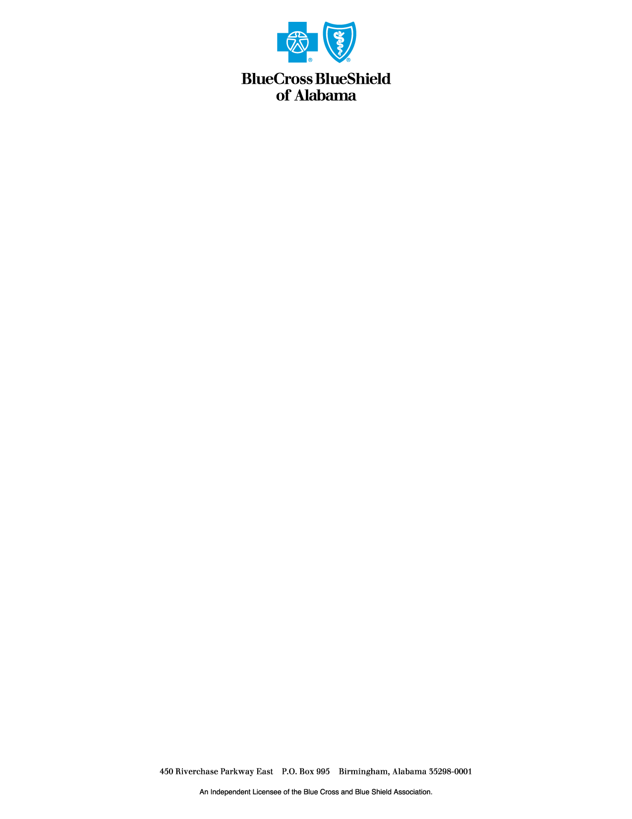

**Media Release**  **Contact: Koko Mackin**

**September 3, 2020** **205-220-2713**

**Blue Cross and Blue Shield of Alabama Receives Brand Excellence Award**

**Birmingham, AL** — Blue Cross and Blue Shield of Alabama is the proud recipient of the 2019 Brand Excellence Award for “Member Retention” from the Blue Cross Blue Shield Association. Blue Cross and Blue Shield of Alabama has won a total of 24 Brand Excellence Awards since the inception of this annual awards program.

The annual awards honor Blue Cross and Blue Shield Plans that excel in developing and enhancing the overall Blue Cross and Blue Shield brand image.

Blue Cross and Blue Shield of Alabama was awarded the Brand Excellence Award in the “Member Retention” category for having the highest percentage of members to renew their coverage over the past year in the state. Blue Cross and Blue Shield of Alabama currently serves more than 2.9 million members.

“In the midst of the current coronavirus healthcare crisis, this award is a great reminder of the importance of taking care of our customers and giving them peace of mind that we are always here for them,” said Tim Vines, President and CEO, Blue Cross and Blue Shield of Alabama. “It is truly an honor to receive this prestigious award. We know our customers have a choice when they select their insurance carrier, and we don’t take that for granted.”

“Even as we focus our leadership efforts on the current COVID-19 pandemic, it’s important that we recognize the great work Blue Cross Plans did in 2019 to foster Americans’ trust in the Blue Brands,” said Scott Serota, President and CEO of the Blue Cross Blue Shield Association. “I am pleased the Brand Enhancement and Protection Committee awarded Blue Cross and Blue Shield of Alabama a Brand Excellence Award for Member Retention.”

This marks the 25th year the Association has presented Brand Excellence Awards to recognize Blue Cross Blue Shield Plans nationwide in categories that promote the BCBS brand, including enrollment growth, member retention and brand innovation.

***About Blue Cross and Blue Shield of Alabama***

Blue Cross and Blue Shield of Alabama has insured Alabamians for over 84 years. Blue Cross offers coverage plans to corporations, individuals and the senior market. For more information about Blue Cross, visit [AlabamaBlue.com](http://www.AlabamaBlue.com). Connect with us on [Facebook](https://www.facebook.com/BCBSAL/?fref=ts), check out our videos on [YouTube](https://www.youtube.com/user/BCBSofAlabama) and follow us on [Twitter](https://twitter.com/BCBSofAlabama) for more up-to-date information.

Blue Cross and Blue Shield of Alabama is an independent licensee of the Blue Cross and Blue Shield Association.

***About the Blue Cross Blue Shield Association***

The Blue Cross and Blue Shield Association is a national federation of 36 independent, community-based and locally operated Blue Cross and Blue Shield companies that collectively provide health care coverage for one in three Americans. BCBSA provides health care insights through [The Health of America Report](https://www.bcbs.com/about-us/capabilities-initiatives/health-america-initiative/health-america-report) series and the national BCBS Health Index. For more information on BCBSA and its member companies, please visit [bcbs.com](http://bcbs.com/). We also encourage you to connect with us on [Facebook](https://www.facebook.com/BCBSAssociation), check out our videos on [YouTube](https://www.youtube.com/user/bluecrossblueshield), follow us on [Twitter](https://twitter.com/BCBSAssociation).

-2-